[PREREQUISITES](https://github.com/IBM-EPBL/IBM-Project-2641-1658478693/tree/main/Project%20Design%20%26%20Planning/Ideation%20Phase/Prerequisites)

Python Installation

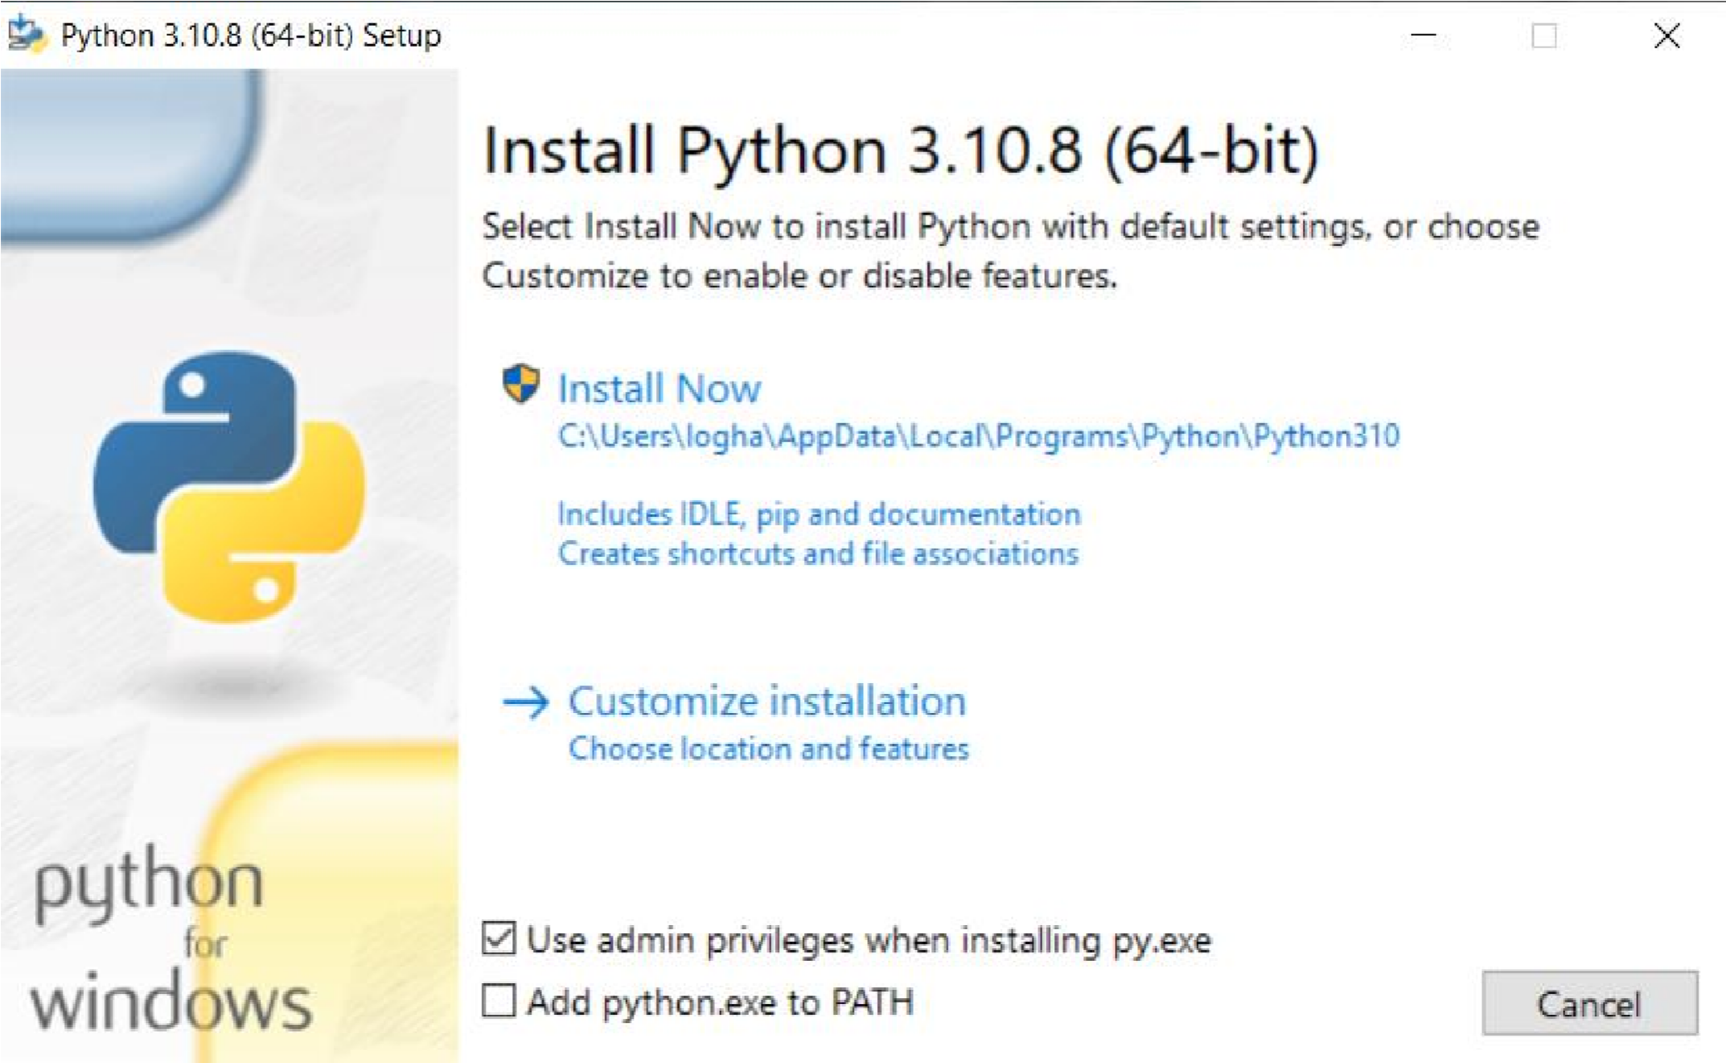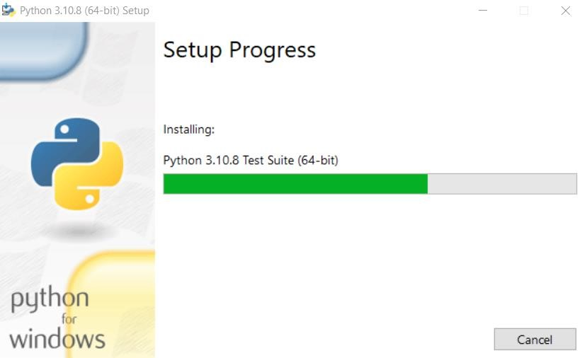

|  |  |
| --- | --- |
| Team ID | PNT2022TMID31875 |
| Project Name | Child monitoring system and Notification |

